CHAPTER 7
Structural Organisation in Animals
• Structural Organisation in Animals

In unicellular organisms, all functions like digestion, respiration and reproduction are performed by a single cell. In the complex body of multicellular animals the same basic functions are carried out by different groups of cells in a well organised manner.
The body of a simple organism like Hydra is made of different types of cells, and the number of cells in each type can be in thousands. The human body is composed of billions of cells to perform various functions.
• Tissue - in multicellular animals, a group of similar cells along with intercellular substances that together perform a specific function (one or more functions) in the body.
Tissues are organised in specific proportion and pattern to form an organ like stomach, lung, heart and kidney. When two or more organs perform a common function by their physical and/or chemical interaction, they together form an organ system, e.g., digestive system, respiratory system, etc.
Cells, tissues, organs and organ systems split up the work in a way that exhibits division of labour and contribute to the survival of the body as a whole.
7.1 | Animal Tissues

The structure of the cells vary according to their function. Therefore, the tissues are different and are broadly classified into four types: (i) Epithelial, (ii) Connective, (iii) Muscular and (iv) Neural.
7.1.1 | Epithelial Tissue

We commonly refer to an epithelial tissue as epithelium (pl.: epithelia). This tissue has a free surface, which faces either a body fluid or the outside environment and thus provides a covering or a lining for some part of the body. Epithelia are sheet-like tissues lining the body's surface and its cavities, ducts and tubes.
The cells are compactly packed with little intercellular matrix. There are two types of epithelial tissues namely simple epithelium and compound epithelium. Simple epithelium is composed of a single layer of cells and functions as a lining for body cavities, ducts and tubes. The compound epithelium consists of two or more cell layers and has a protective function as it does in our skin.
On the basis of structural modification of the cells, simple epithelium is further divided into three types (Figure 7.1): (i) Squamous, (ii) Cuboidal, (iii) Columnar.
Simple epithelium | Structure | Location | Main function
Squamous | Single thin layer of flattened cells with irregular boundaries | Walls of blood vessels and air sacs of lungs | Forms a diffusion boundary
Cuboidal | Single layer of cube-like cells | Ducts of glands and tubular parts of nephrons in kidneys | Secretion and absorption
Columnar | Single layer of tall and slender cells; nuclei at the base; free surface may have microvilli | Lining of stomach and intestine | Secretion and absorption

The epithelium of the proximal convoluted tubule (PCT) of the nephron in the kidney has microvilli.
• If the columnar or cuboidal cells bear cilia on their free surface they are called ciliated epithelium (Figure 7.1d). Their function is to move particles or mucus in a specific direction over the epithelium. They are mainly present in the inner surface of hollow organs like bronchioles and fallopian tubes.
• Some of the columnar or cuboidal cells get specialised for secretion and are called glandular epithelium (Figure 7.2). They are mainly of two types: unicellular, consisting of isolated glandular cells (goblet cells of the alimentary canal), and multicellular, consisting of a cluster of cells (salivary gland).
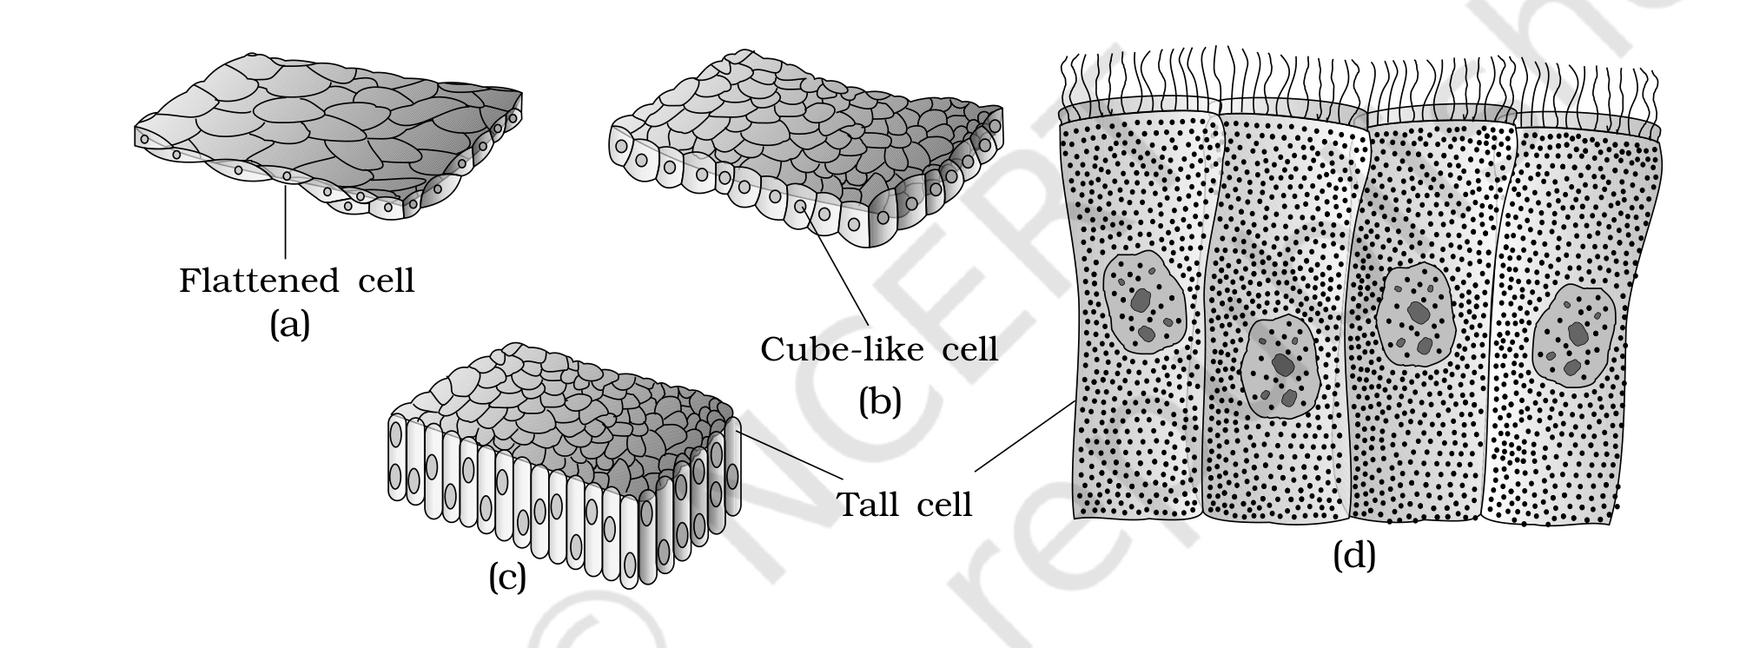
Figure 7.1 Simple epithelium: (a) Squamous (b) Cuboidal (c) Columnar (d) Columnar cells bearing cilia
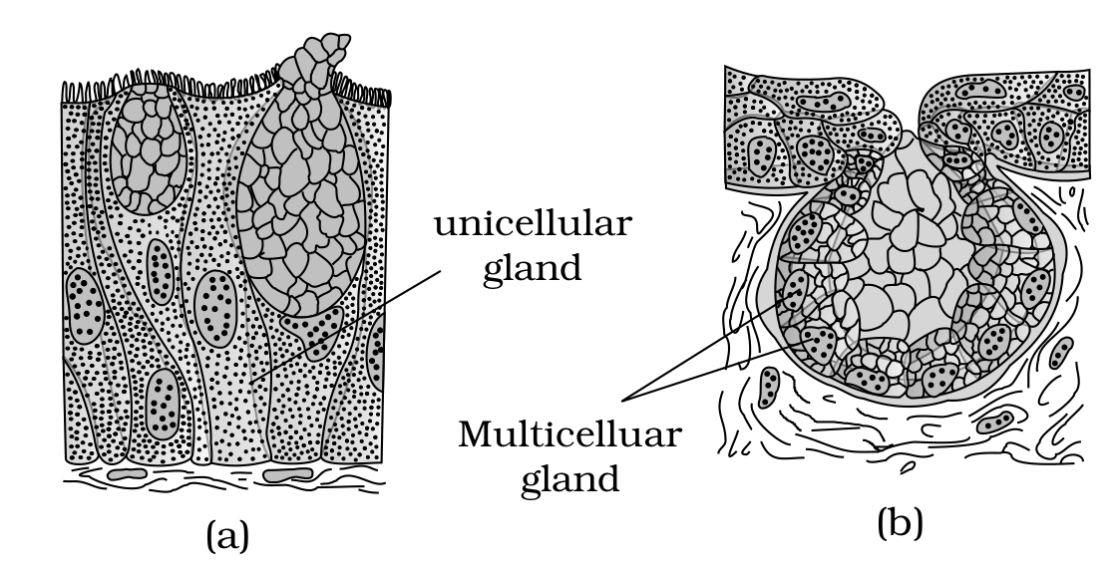
Figure 7.2 Glandular epithelium: (a) Unicellular (b) Multicellular
On the basis of the mode of pouring of their secretions, glands are divided into two categories namely exocrine and endocrine glands.
Gland type | Duct | Secretions
Exocrine | Products released through ducts or tubes | Mucus, saliva, earwax, oil, milk, digestive enzymes and other cell products
Endocrine | Do not have ducts | Hormones, secreted directly into the fluid bathing the gland

Compound epithelium is made of more than one layer (multi-layered) of cells and thus has a limited role in secretion and absorption (Figure 7.3). Their main function is to provide protection against chemical and mechanical stresses. They cover the dry surface of the skin, the moist surface of buccal cavity, pharynx, inner lining of ducts of salivary glands and of pancreatic ducts.
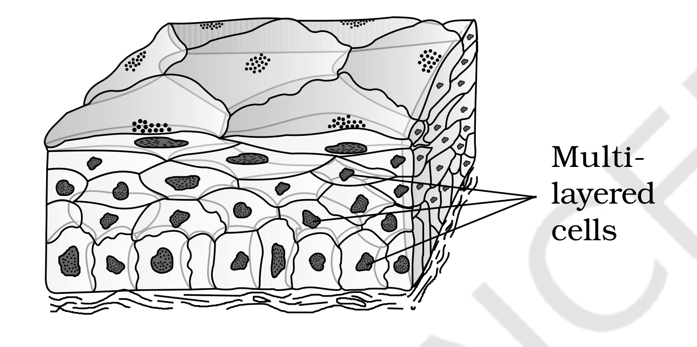
Figure 7.3 Compound epithelium
All cells in epithelium are held together with little intercellular material. In nearly all animal tissues, specialised junctions provide both structural and functional links between its individual cells. Three types of cell junctions are found in the epithelium and other tissues. These are called tight, adhering and gap junctions.
Cell junction | Function
Tight junctions | Help to stop substances from leaking across a tissue
Adhering junctions | Perform cementing to keep neighbouring cells together
Gap junctions | Facilitate the cells to communicate with each other by connecting the cytoplasm of adjoining cells, for rapid transfer of ions, small molecules and sometimes big molecules

7.1.2 | Connective Tissue

Connective tissues are most abundant and widely distributed in the body of complex animals. They are named connective tissues because of their special function of linking and supporting other tissues/organs of the body. Diverse types of connective tissues bind together, support, strengthen, protect, and insulate other tissue in the body. Connective tissue covers all three of the other tissue types.
They range from soft connective tissues to specialised types, which include cartilage, bone, adipose, and blood. In all connective tissues except blood, the cells secrete fibres of structural proteins called collagen or elastin. The fibres provide strength, elasticity and flexibility to the tissue. These cells also secrete modified polysaccharides, which accumulate between cells and fibres and act as matrix (ground substance). In short, soft connective tissues consist of protein fibres as well as a variety of cells arranged in a ground substance.
Connective tissues are classified into three types: (i) Loose connective tissue, (ii) Dense connective tissue and (iii) Specialised connective tissue.
A | Loose Connective Tissue

• Loose connective tissue has cells and fibres loosely arranged in a semi-fluid ground substance, for example, areolar tissue present beneath the skin (Figure 7.4). Often it serves as a support framework for epithelium. It contains fibroblasts (cells that produce and secrete fibres), macrophages and mast cells.
• Adipose tissue is another type of loose connective tissue located mainly beneath the skin. The cells of this tissue are specialised to store fats. The excess of nutrients which are not used immediately are converted into fats and are stored in this tissue. Thus adipose tissue is a reservoir of stored energy.
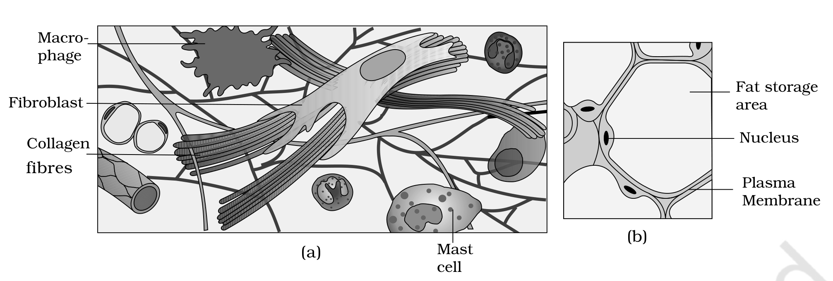
Figure 7.4 Loose connective tissue: (a) Areolar tissue (b) Adipose tissue
B | Dense Connective Tissue

Fibres and fibroblasts are compactly packed in the dense connective tissues. Orientation of fibres shows a regular or irregular pattern and they are called dense regular and dense irregular tissues.
• In the dense regular connective tissues, the collagen fibres are present in rows between many parallel bundles of fibres. Tendons, which attach skeletal muscles to bones, and ligaments, which attach one bone to another, are examples of this tissue.
• Dense irregular connective tissue has fibroblasts and many fibres (mostly collagen) that are oriented differently (Figure 7.5). This tissue is present in the skin.
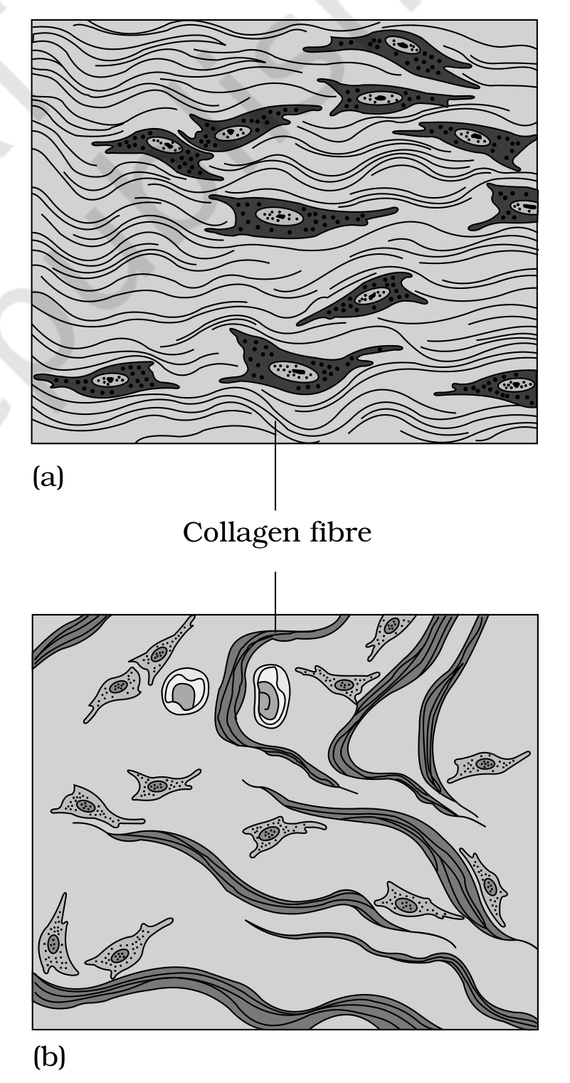
Figure 7.5 Dense connective tissue: (a) Dense regular (b) Dense irregular
C | Specialised Connective Tissue

Cartilage, bones and blood are various types of specialised connective tissues. (The chapter summary classifies cartilage, bone, blood, and adipose tissue together as specialised connective tissues; section 7.1.2 above first classifies adipose as a loose connective tissue. Both source statements are preserved as written.) Cartilage and bone are both structural materials.
• Cartilage - its intercellular material is solid and pliable and resists compression. Cells of this tissue (chondrocytes) are enclosed in small cavities within the matrix secreted by them (Figure 7.6a).
• Most of the cartilages in vertebrate embryos are replaced by bones in adults. In adults, cartilage is present in the tip of nose, outer ear joints, between adjacent bones of the vertebral column, limbs and hands.
• Bone - has a hard and non-pliable ground substance rich in calcium salts and collagen fibres which give bone its strength (Figure 7.6b). It is the main tissue that provides structural frame to the body.
• Bones support and protect softer tissues and organs. The bone cells (osteocytes) are present in the spaces called lacunae.
• Limb bones, such as the long bones of the legs, serve weight-bearing functions. They also interact with skeletal muscles attached to them to bring about movements. The bone marrow in some bones is the site of production of blood cells.
• Blood - a fluid connective tissue containing plasma, red blood cells (RBC), white blood cells (WBC) and platelets (Figure 7.6c). It is the main circulating fluid that helps in the transport of various substances.
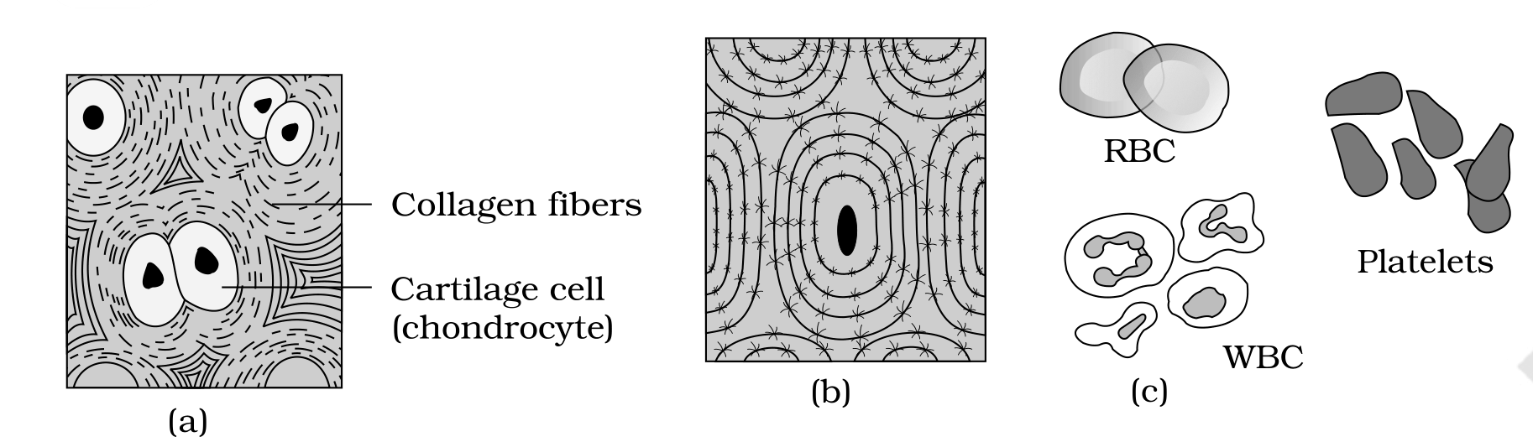
Figure 7.6 Specialised connective tissues: (a) Cartilage (b) Bone (c) Blood
7.1.3 | Muscle Tissue

Each muscle is made of many long, cylindrical fibres arranged in parallel arrays. These fibres are composed of numerous fine fibrils, called myofibrils. Muscle fibres contract (shorten) in response to stimulation, then relax (lengthen) and return to their uncontracted state in a coordinated fashion. Their action moves the body to adjust to changes in the environment and to maintain the positions of the various parts of the body. In general, muscles play an active role in all the movements of the body.
Muscles are of three types: skeletal, smooth, and cardiac (Figure 7.7).
Muscle | Striations | Location | Control / junctions
Skeletal | Striated (striped) | Closely attached to skeletal bones; e.g., biceps - fibres bundled in a parallel fashion, several bundles enclosed by a sheath of tough connective tissue | Voluntary
Smooth | No striations; fibres taper at both ends (fusiform) | Wall of internal organs such as blood vessels, stomach and intestine | Involuntary - functioning cannot be directly controlled; cell junctions hold fibres together, bundled in a connective tissue sheath
Cardiac | Contractile tissue | Present only in the heart | Cell junctions fuse the plasma membranes; communication junctions (intercalated discs) let the cells contract as a unit

Cardiac muscle makes up the contractile walls of the heart: when one cell receives a signal to contract, its neighbours are also stimulated to contract.
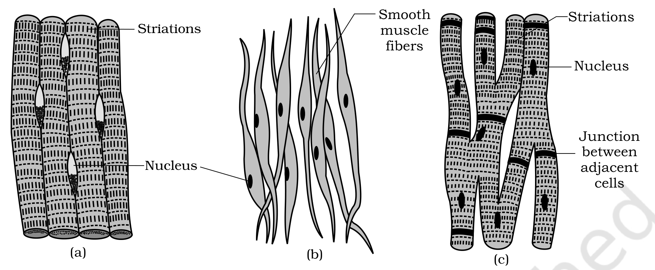
Figure 7.7 Muscle tissue: (a) Skeletal (striated) muscle tissue (b) Smooth muscle tissue (c) Cardiac muscle tissue
7.1.4 | Neural Tissue

Neural tissue exerts the greatest control over the body's responsiveness to changing conditions. Neurons, the unit of the neural system, are excitable cells (Figure 7.8). The neuroglial cells, which constitute the rest of the neural system, protect and support neurons. Neuroglia make up more than one-half the volume of neural tissue in our body.
When a neuron is suitably stimulated, an electrical disturbance is generated which swiftly travels along its plasma membrane. Arrival of the disturbance at the neuron's endings, or output zone, triggers events that may cause stimulation or inhibition of adjacent neurons and other cells.
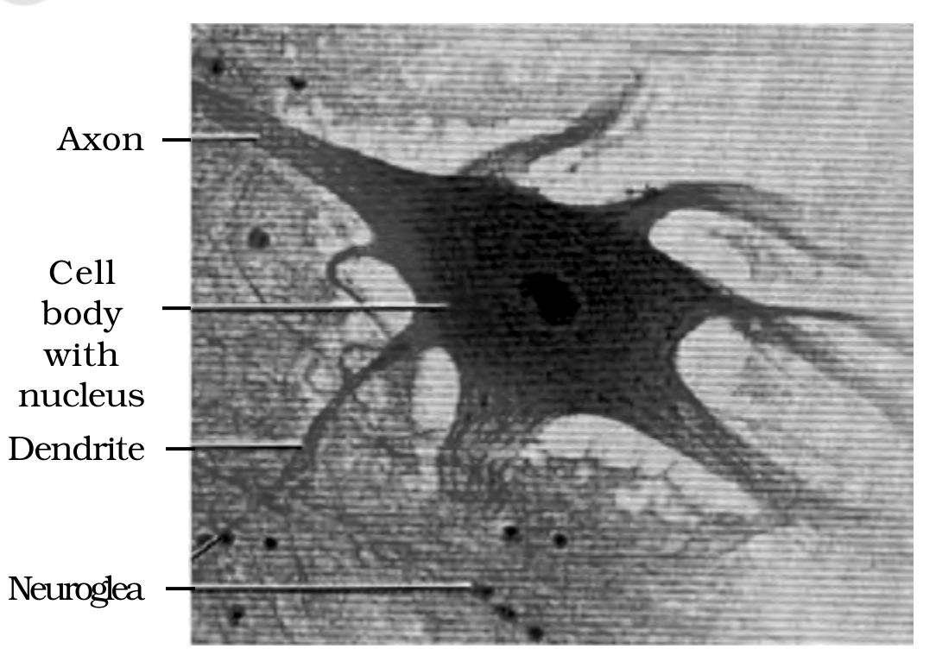
Figure 7.8 Neural tissue (Neuron with neuroglea)
7.2 | Organ and Organ System

The basic tissues mentioned above organise to form organs which in turn associate to form organ systems in the multicellular organisms. Such an organisation is essential for more efficient and better coordinated activities of millions of cells constituting an organism. Each organ in our body is made of one or more type of tissues. For example, our heart consists of all the four types of tissues - epithelial, connective, muscular and neural.
The complexity in organ and organ systems shows a discernable trend, called the evolutionary trend (details in class XII).
• Morphology - the study of form or externally visible features. In plants or microbes, the term morphology precisely means only this; in animals it refers to the external appearance of the organs or parts of the body.
• Anatomy - conventionally used for the study of the morphology of internal organs in animals.
[NOTE] In the requested NEET syllabus, the Earthworm (section 7.3) has been removed, so the chapter continues from the general organ/organ-system idea directly to the Cockroach and the Frog as the worked examples of animal organisation.

7.4 | Cockroach

Cockroaches are brown or black bodied animals that are included in class Insecta of Phylum Arthropoda. Bright yellow, red and green coloured cockroaches have also been reported in tropical regions.
• Their size ranges from 1/4 inches to 3 inches (0.6-7.6 cm) and they have long antennae, legs and a flat extension of the upper body wall that conceals the head.
• They are nocturnal omnivores that live in damp places throughout the world. They have become residents of human homes and thus are serious pests and vectors of several diseases.
7.4.1 | Morphology

The adults of the common species of cockroach, Periplaneta americana, are about 34-53 mm long with wings that extend beyond the tip of the abdomen in males. The body of the cockroach is segmented and divisible into three distinct regions - head, thorax and abdomen (Figure 7.14).
The entire body is covered by a hard chitinous exoskeleton (brown in colour). In each segment, the exoskeleton has hardened plates called sclerites (tergites dorsally and sternites ventrally) that are joined to each other by a thin and flexible articular membrane (arthrodial membrane).
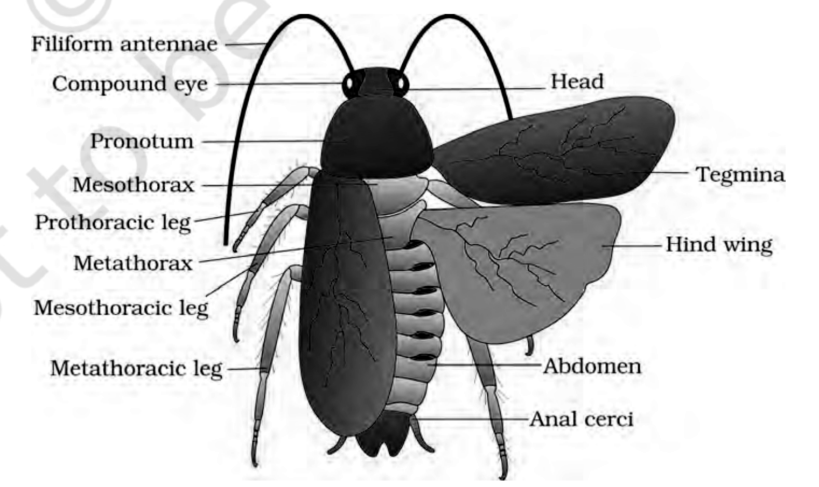
Figure 7.14 External features of cockroach
Head | Head

The head is triangular in shape and lies anteriorly at right angles to the longitudinal body axis. It is formed by the fusion of six segments and shows great mobility in all directions due to a flexible neck (Figure 7.15).
• The head capsule bears a pair of compound eyes. A pair of thread-like antennae arise from membranous sockets lying in front of the eyes; antennae have sensory receptors that help in monitoring the environment.
• The anterior end of the head bears appendages forming biting and chewing type of mouthparts, consisting of a labrum (upper lip), a pair of mandibles, a pair of maxillae and a labium (lower lip). A median flexible lobe, acting as a tongue (hypopharynx), lies within the cavity enclosed by the mouthparts (Figure 7.15b).
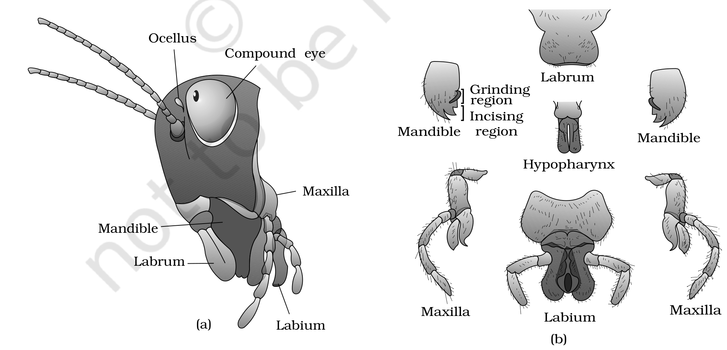
Figure 7.15 Head region of cockroach: (a) parts of head region (b) mouth parts
Thorax | Thorax

The thorax consists of three parts - prothorax, mesothorax and metathorax. The head is connected with the thorax by a short extension of the prothorax known as the neck. Each thoracic segment bears a pair of walking legs.
• The first pair of wings arises from the mesothorax and the second pair from the metathorax. (Thus two pairs of wings are present, one pair each on the 2nd and 3rd thoracic segment.)
• Forewings (mesothoracic) called tegmina are opaque, dark and leathery and cover the hind wings when at rest. The hind wings are transparent, membranous and are used in flight.
Abdomen | Abdomen

The abdomen in both males and females consists of 10 segments.
• In females, the 7th sternum is boat-shaped and together with the 8th and 9th sterna forms a brood or genital pouch whose anterior part contains the female gonopore, spermathecal pores and collateral glands.
• In males, the genital pouch or chamber lies at the hind end of the abdomen, bounded dorsally by the 9th and 10th terga and ventrally by the 9th sternum. It contains the dorsal anus, ventral male genital pore and gonapophysis.
• Males bear a pair of short, thread-like anal styles which are absent in females. In both sexes, the 10th segment bears a pair of jointed filamentous structures called anal cerci.
7.4.2 | Anatomy

Dig | Digestive System

The alimentary canal present in the body cavity is divided into three regions: foregut, midgut and hindgut (Figure 7.16). A pair of salivary glands is present near the crop.
1 | The mouth opens into a short tubular pharynx, leading to a narrow tubular passage called the oesophagus.
2 | The oesophagus opens into a sac-like structure called the crop, used for storing food.
3 | The crop is followed by the gizzard or proventriculus: it has an outer layer of thick circular muscles and a thick inner cuticle forming six highly chitinous plates called teeth, and it helps in grinding the food particles. The entire foregut is lined by cuticle.
4 | A ring of 6-8 blind tubules called hepatic or gastric caeca is present at the junction of foregut and midgut, which secrete digestive juice.
5 | At the junction of midgut and hindgut is present another ring of 100-150 yellow coloured thin filamentous Malpighian tubules, which help in removal of excretory products from haemolymph.
6 | The hindgut is broader than the midgut and is differentiated into ileum, colon and rectum; the rectum opens out through the anus.

Circ | Circulatory System

The blood vascular system of cockroach is an open type (Figure 7.17). Blood vessels are poorly developed and open into a space (haemocoel). Visceral organs located in the haemocoel are bathed in blood (haemolymph). The haemolymph is composed of colourless plasma and haemocytes.
The heart of cockroach consists of an elongated muscular tube lying along the mid-dorsal line of thorax and abdomen. It is differentiated into funnel-shaped chambers with ostia on either side. Blood from sinuses enters the heart through ostia and is pumped anteriorly to the sinuses again.
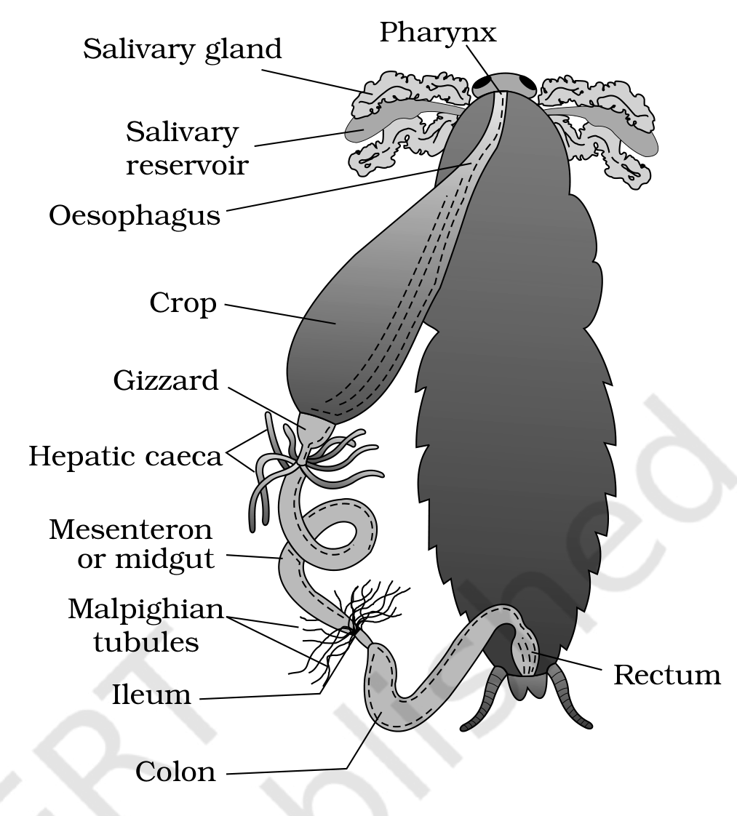  Figure 7.16 Alimentary canal of cockroach | 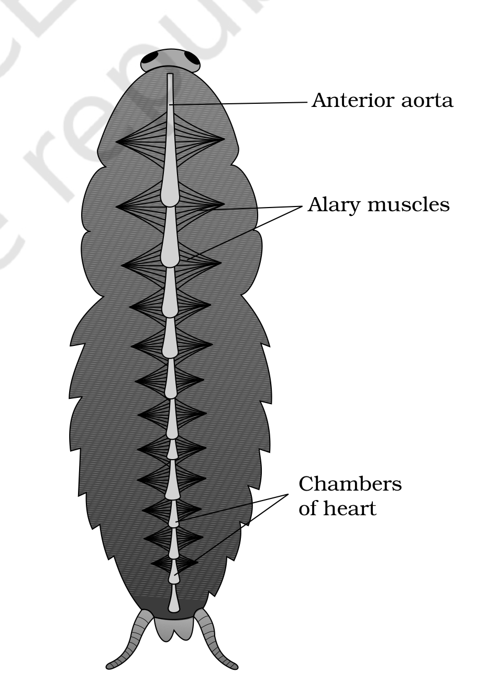  Figure 7.17 Open circulatory system of cockroach

Resp | Respiratory System

The respiratory system consists of a network of trachea, that open through 10 pairs of small holes called spiracles present on the lateral side of the body. Thin branching tubes (tracheal tubes subdivided into tracheoles) carry oxygen from the air to all the parts. The opening of the spiracles is regulated by the sphincters. Exchange of gases takes place at the tracheoles by diffusion.
Excr | Excretory System

Excretion is performed by Malpighian tubules. Each tubule is lined by glandular and ciliated cells. They absorb nitrogenous waste products and convert them into uric acid which is excreted out through the hindgut. Therefore, this insect is called uricotelic. In addition, the fat body, nephrocytes and urecose glands also help in excretion.
Nerv | Nervous System

The nervous system of cockroach consists of a series of fused, segmentally arranged ganglia joined by paired longitudinal connectives on the ventral side. Three ganglia lie in the thorax, and six in the abdomen. The nervous system is spread throughout the body: the head holds a bit of it while the rest is situated along the ventral (belly-side) part of the body.
[NOTE] Because the nervous system is spread out, if the head of a cockroach is cut off it will still live for as long as one week.

In the head region, the brain is represented by the supra-oesophageal ganglion which supplies nerves to the antennae and compound eyes. In cockroach, the sense organs are antennae, eyes, maxillary palps, labial palps, anal cerci, etc.
The compound eyes are situated at the dorsal surface of the head. Each eye consists of about 2000 hexagonal ommatidia (sing.: ommatidium). With the help of several ommatidia, a cockroach can receive several images of an object. This kind of vision is known as mosaic vision, with more sensitivity but less resolution, being common during night (hence called nocturnal vision).
Repr | Reproductive System

Cockroaches are dioecious and both sexes have well developed reproductive organs (Figure 7.18).
• The male reproductive system consists of a pair of testes, one lying on each lateral side in the 4th-6th abdominal segments. From each testis arises a thin vas deferens, which opens into the ejaculatory duct through the seminal vesicle. The ejaculatory duct opens into the male gonopore situated ventral to the anus.
• A characteristic mushroom-shaped gland is present in the 6th-7th abdominal segments which functions as an accessory reproductive gland. The external genitalia are represented by male gonapophysis or phallomere (chitinous asymmetrical structures surrounding the male gonopore).
• The sperms are stored in the seminal vesicles and are glued together in the form of bundles called spermatophores which are discharged during copulation.
• The female reproductive system consists of two large ovaries, lying laterally in the 2nd-6th abdominal segments. Each ovary is formed of a group of eight ovarian tubules or ovarioles, containing a chain of developing ova. Oviducts of each ovary unite into a single median oviduct (also called vagina) which opens into the genital chamber.
• A pair of spermatheca is present in the 6th segment which opens into the genital chamber. Sperms are transferred through spermatophores.
• Their fertilised eggs are encased in capsules called oothecae. An ootheca is a dark reddish to blackish brown capsule, about 3/8 inch (8 mm) long. They are dropped or glued to a suitable surface, usually in a crack or crevice of high relative humidity near a food source. On an average, females produce 9-10 oothecae, each containing 14-16 eggs.
• The development of P. americana is paurometabolous, meaning there is development through a nymphal stage. The nymphs look very much like adults. The nymph grows by moulting about 13 times to reach the adult form. The next to last nymphal stage has wing pads but only adult cockroaches have wings. (After the rupturing of a single ootheca, sixteen young ones, called nymphs, come out.)
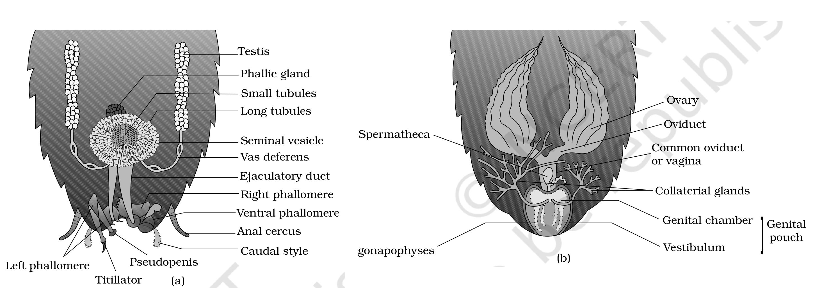
Figure 7.18 Reproductive system of cockroach: (a) male (b) female
Many species of cockroaches are wild and are of no known economic importance yet. A few species thrive in and around human habitat. They are pests because they spoil food and contaminate it with their smelly excreta, and they can transmit a variety of bacterial diseases by contaminating food material.
7.5 | Frogs

Frogs can live both on land and in freshwater and belong to class Amphibia of phylum Chordata. The most common species of frog found in India is Rana tigrina. They do not have a constant body temperature - their body temperature varies with the temperature of the environment; such animals are called cold blooded or poikilotherms.
• Frogs change colour on grasses and dry land to hide from predators (camouflage); this protective coloration is called mimicry.
• Frogs are not seen during peak summer and winter. During this period they take shelter in deep burrows to protect them from extreme heat and cold. This is known as summer sleep (aestivation) and winter sleep (hibernation) respectively.
7.5.1 | Morphology

The skin of a frog is smooth and slippery due to the presence of mucus and is always maintained in a moist condition. Mucous glands are present in the skin, which is highly vascularised and helps in respiration both in water and on land. The colour of the dorsal side of the body is generally olive green with dark irregular spots, while on the ventral side the skin is uniformly pale yellow. The frog never drinks water but absorbs it through the skin.
The body of a frog is divisible into head and trunk (Figure 7.19); a neck and tail are absent.
• Above the mouth, a pair of nostrils is present. Eyes are bulged and covered by a nictitating membrane that protects them while in water. On either side of the eyes a membranous tympanum (ear) receives sound signals.
• The forelimbs and hind limbs help in swimming, walking, leaping and burrowing. The hind limbs end in five digits and are larger and muscular than the fore limbs that end in four digits. Feet have webbed digits that help in swimming.
• Frogs exhibit sexual dimorphism. Male frogs can be distinguished by the presence of sound producing vocal sacs and also a copulatory pad on the first digit of the fore limbs, which are absent in female frogs.
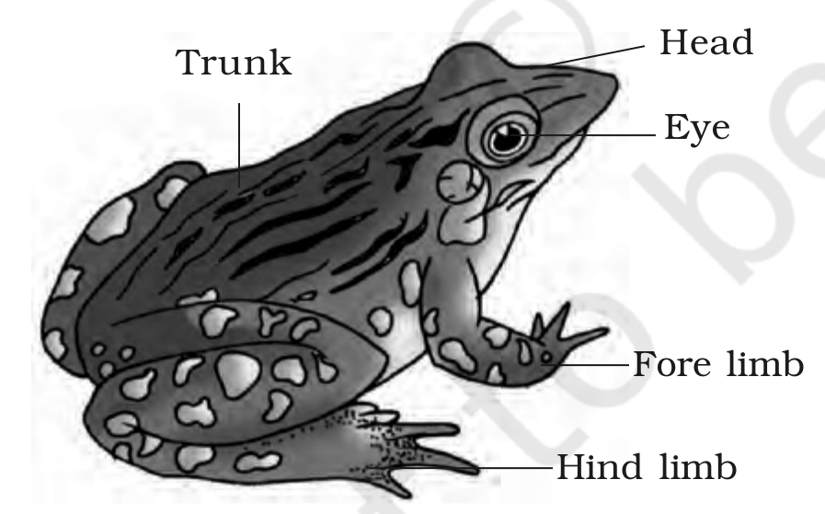
Figure 7.19 External features of frog
7.5.2 | Anatomy

The body cavity of frogs accommodates different organ systems - digestive, circulatory, respiratory, nervous, excretory and reproductive - with well developed structures and functions (Figure 7.20).
Dig | Digestive System

The digestive system consists of the alimentary canal and digestive glands. The alimentary canal is short because frogs are carnivores and hence the length of the intestine is reduced. Food is captured by the bilobed tongue.
1 | The mouth opens into the buccal cavity that leads to the oesophagus through the pharynx.
2 | The oesophagus is a short tube that opens into the stomach. Digestion of food takes place by the action of HCl and gastric juices secreted from the walls of the stomach.
3 | Partially digested food called chyme passes from the stomach to the first part of the small intestine, the duodenum, which receives bile from the gall bladder and pancreatic juices from the pancreas through a common bile duct.
4 | Bile emulsifies fat and pancreatic juices digest carbohydrates and proteins; final digestion takes place in the intestine.
5 | Digested food is absorbed by the numerous finger-like folds in the inner wall of the intestine called villi and microvilli.
6 | The undigested solid waste moves into the rectum and passes out through the cloaca.

The main digestive glands are the liver, which secretes bile that is stored in the gall bladder, and the pancreas, which produces pancreatic juice containing digestive enzymes.
Resp | Respiratory System

Frogs respire on land and in the water by two different methods. In water, the skin acts as the aquatic respiratory organ (cutaneous respiration) - dissolved oxygen in the water is exchanged through the skin by diffusion. On land, the buccal cavity, skin and lungs act as the respiratory organs; respiration by lungs is called pulmonary respiration.
• The lungs are a pair of elongated, pink coloured sac-like structures present in the upper part of the trunk region (thorax). Air enters through the nostrils into the buccal cavity and then to the lungs. During aestivation and hibernation, gaseous exchange takes place through the skin.
Circ | Circulatory System

The vascular system of frog is a well-developed closed type. Frogs also have a lymphatic system. The blood vascular system involves heart, blood vessels and blood; the lymphatic system consists of lymph, lymph channels and lymph nodes. The circulatory system is closed with single circulation.
• The heart is a muscular structure situated in the upper part of the body cavity. It has three chambers - two atria and one ventricle - and is covered by a membrane called pericardium. A triangular structure called the sinus venosus joins the right atrium and receives blood through the major veins called the vena cava. The ventricle opens into a sac-like conus arteriosus on the ventral side of the heart.
• The blood from the heart is carried to all parts of the body by the arteries (arterial system). The veins collect blood from different parts of the body to the heart and form the venous system. Special venous connections are present: between liver and intestine (the hepatic portal system) and between the kidney and lower parts of the body (the renal portal system).
• The blood is composed of plasma and cells. The blood cells are RBC (red blood cells) or erythrocytes, WBC (white blood cells) or leucocytes and platelets. RBCs are nucleated and contain the red coloured pigment haemoglobin.
• The lymph is different from blood - it lacks few proteins and RBCs. The blood carries nutrients, gases and water to the respective sites during circulation, which is achieved by the pumping action of the muscular heart.
Excr | Excretory System

The elimination of nitrogenous wastes is carried out by a well developed excretory system consisting of a pair of kidneys, ureters, cloaca and urinary bladder. The kidneys are compact, dark red and bean-like structures situated a little posteriorly in the body cavity on both sides of the vertebral column. Each kidney is composed of several structural and functional units called uriniferous tubules or nephrons.
• Two ureters emerge from the kidneys in male frogs; the ureters act as a urinogenital duct which opens into the cloaca. In females, the ureters and oviduct open separately in the cloaca. The thin-walled urinary bladder is present ventral to the rectum and also opens into the cloaca.
• The frog excretes urea and thus is a ureotelic animal. Excretory wastes are carried by blood into the kidney where they are separated and excreted.
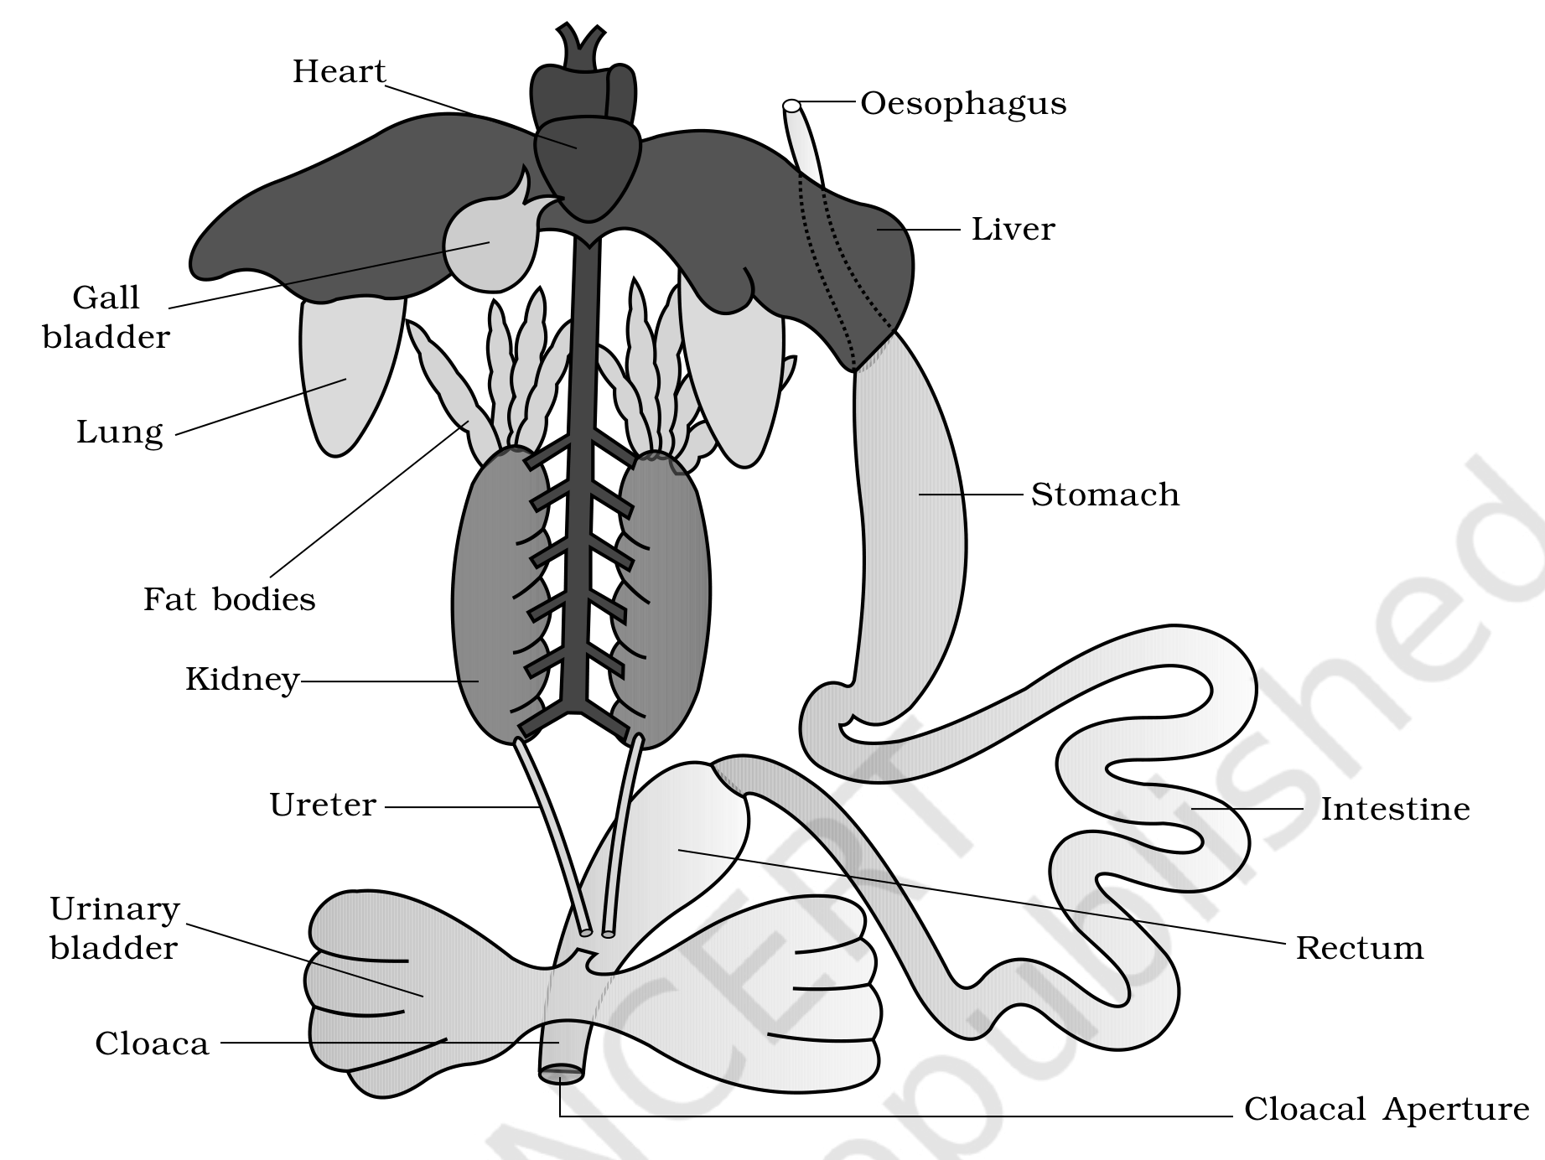
Figure 7.20 Diagrammatic representation of internal organs of frog showing complete digestive system
Ctrl | Control and Coordination

The system for control and coordination is highly evolved in the frog and includes both the neural system and endocrine glands. The chemical coordination of various organs is achieved by hormones secreted by the endocrine glands. The prominent endocrine glands found in the frog are the pituitary, thyroid, parathyroid, thymus, pineal body, pancreatic islets, adrenals and gonads.
• The nervous system is organised into a central nervous system (brain and spinal cord), a peripheral nervous system (cranial and spinal nerves) and an autonomic nervous system (sympathetic and parasympathetic). There are ten pairs of cranial nerves arising from the brain.
• The brain is enclosed in a bony structure called the brain box (cranium) and is divided into fore-brain, mid-brain and hind-brain. The forebrain includes olfactory lobes, paired cerebral hemispheres and unpaired diencephalon; the midbrain is characterised by a pair of optic lobes; the hind-brain consists of cerebellum and medulla oblongata. The medulla oblongata passes out through the foramen magnum and continues into the spinal cord, which is enclosed in the vertebral column.
• The frog has different types of sense organs: organs of touch (sensory papillae), taste (taste buds), smell (nasal epithelium), vision (eyes) and hearing (tympanum with internal ears). Of these, the eyes and internal ears are well-organised structures and the rest are cellular aggregations around nerve endings.
• Eyes in a frog are a pair of spherical structures situated in the orbit in the skull; these are simple eyes (possessing only one unit). External ear is absent in frogs and only the tympanum can be seen externally. The ear is an organ of hearing as well as balancing (equilibrium).
Repr | Reproductive System

Frogs have well organised male and female reproductive systems.
• Male reproductive organs consist of a pair of yellowish ovoid testes (Figure 7.21), found adhered to the upper part of the kidneys by a double fold of peritoneum called the mesorchium. Vasa efferentia are 10-12 in number and arise from the testes; they enter the kidneys on their side and open into Bidder's canal. Finally it communicates with the urinogenital duct that comes out of the kidneys and opens into the cloaca.
• The cloaca is a small, median chamber used to pass faecal matter, urine and sperms to the exterior.
• The female reproductive organs include a pair of ovaries (Figure 7.22), situated near the kidneys with no functional connection with them. A pair of oviducts arising from the ovaries opens into the cloaca separately. A mature female can lay 2500 to 3000 ova at a time.
• Fertilisation is external and takes place in water. Development involves a larval stage called the tadpole, which undergoes metamorphosis to form the adult.
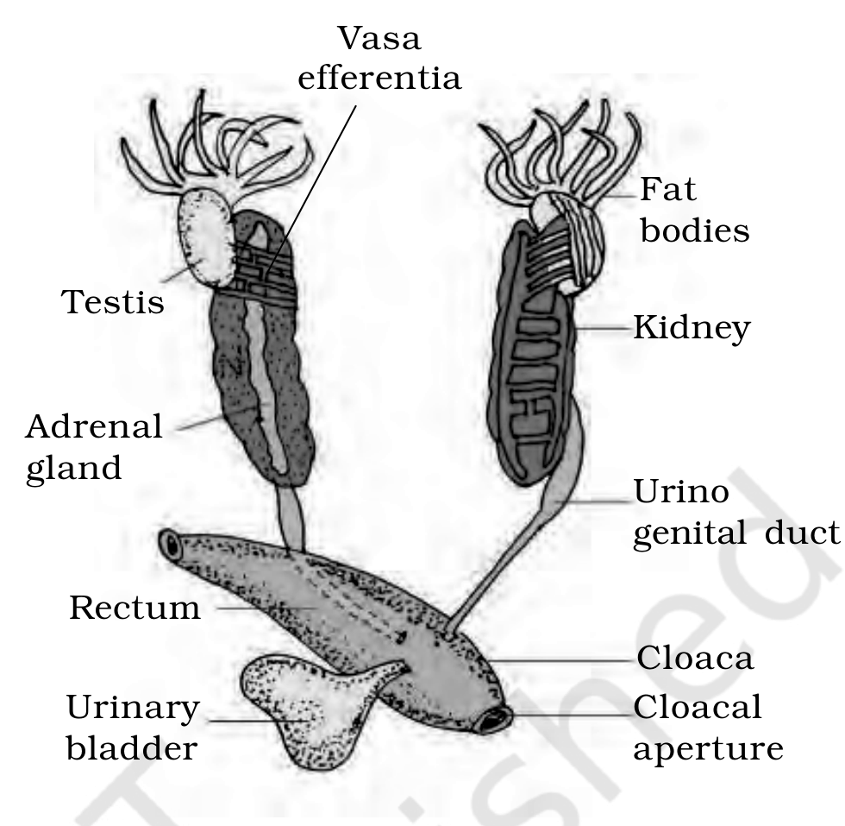  Figure 7.21 Male reproductive system | 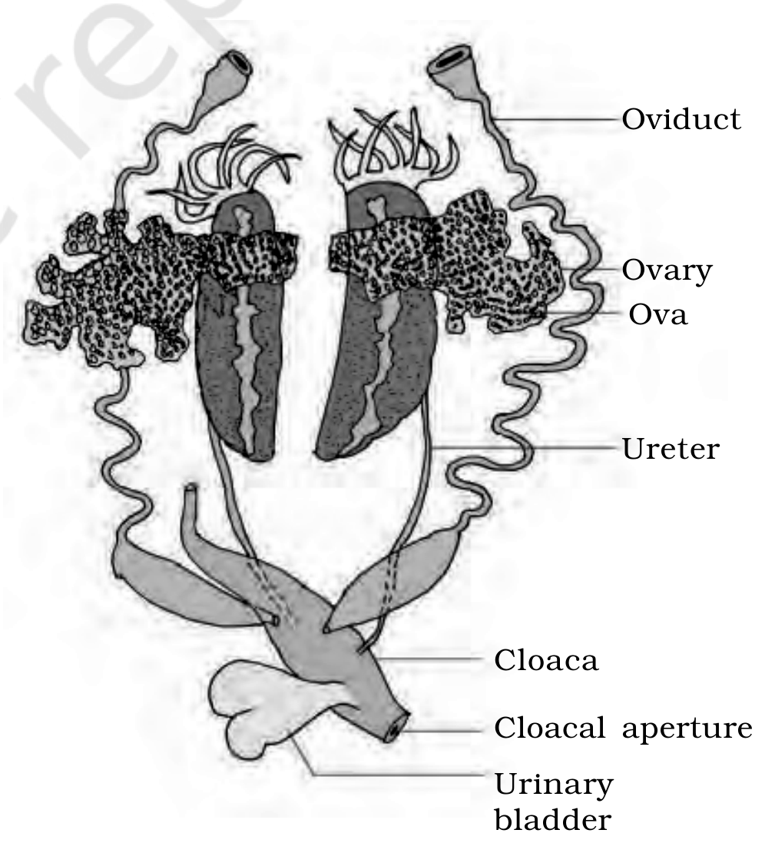  Figure 7.22 Female reproductive system

Frogs are beneficial for mankind because they eat insects and protect the crop. They maintain ecological balance as an important link of the food chain and food web in the ecosystem. In some countries the muscular legs of frog are used as food by man.
Recap | Quick Recap

• A tissue is a group of cells along with intercellular substances performing one or more functions. Cells, tissues, organs and organ systems exhibit division of labour for the survival of the whole body. Complex animals have four tissue types: epithelial, connective, muscular and neural.
• Epithelia are sheet-like tissues lining the body's surface and its cavities, ducts and tubes, with one free surface; their cells are connected at tight, adhering and gap junctions. Simple epithelium is squamous, cuboidal or columnar; compound epithelium is protective.
• Connective tissues bind together, support, strengthen, protect and insulate other tissues, and cover all three other tissue types. Soft connective tissues have protein fibres and varied cells in a ground substance. Cartilage, bone, blood and adipose tissue are specialised connective tissues; cartilage and bone are structural materials, blood is a fluid transport tissue, and adipose tissue is a reservoir of stored energy.
• Muscle tissue contracts in response to stimulation and helps movement. Skeletal muscle is attached to bones, smooth muscle is a component of internal organs, and cardiac muscle makes up the contractile walls of the heart. Nervous tissue exerts the greatest control over the body's responses; neurons are its basic units.
• The body of Cockroach (Periplaneta americana) is covered by a chitinous exoskeleton and divided into head, thorax and abdomen, whose segments bear jointed appendages. The three thoracic segments each bear a pair of walking legs, two pairs of wings are present (one pair each on the 2nd and 3rd segment), and the abdomen has 10 segments.
• The cockroach alimentary canal has a mouth with mouthparts, pharynx, oesophagus, crop, gizzard, midgut, hindgut and anus, with a pair of salivary glands near the crop. Hepatic caecae lie at the foregut-midgut junction and Malpighian tubules at the midgut-hindgut junction (excretion). The blood vascular system is open; respiration is by a network of tracheae opening through spiracles; the nervous system is segmentally arranged ganglia with a ventral nerve cord.
• In the cockroach, a pair of testes is present in the 4th-6th segments and ovaries in the 2nd-6th segments; fertilisation is internal. A female produces 9-10 oothecae bearing developing embryos, and after rupturing of a single ootheca sixteen nymphs come out.
• The Indian bullfrog, Rana tigrina, is covered by skin with mucous glands (highly vascularised, aids respiration in water and on land), and the body is divisible into head and trunk. A muscular bilobed tongue captures prey. Its alimentary canal (oesophagus, stomach, intestine, rectum) opens into the cloaca; the main digestive glands are liver and pancreas.
• The frog can respire through skin in water and lungs on land. Its circulatory system is closed with single circulation and RBCs are nucleated. The nervous system is organised into central, peripheral and autonomic parts. The urinogenital system has kidneys and urinogenital ducts opening into the cloaca.
• The male reproductive organ is a pair of testes and the female a pair of ovaries. A female lays 2500-3000 ova at a time; fertilisation and development are external, and the eggs hatch into tadpoles which metamorphose into frogs.
Appendix | Terms Used in the Exercises

A few exercise questions use terms that the supplied chapter text does not itself define. Those gap terms are answered here so the exercises can be attempted from these notes alone; every other exercise is answerable from the sections and figures above.
• Axon [Q7(b)] - the single long process of a neuron that conducts the nerve impulse away from the cell body, towards the neuron's endings (output zone). It is labelled in Figure 7.8 but not defined in the running text.
• Simple gland vs compound gland [Q9(e)] - a simple gland has an unbranched duct, whereas a compound gland has a branched duct system draining many secretory units. (This is distinct from the unicellular/multicellular classification given in 7.1.1.)
• Coxa [Q10(e)] - the basal segment of an insect leg, which attaches the leg to the thoracic segment. (The cockroach's thoracic segments - mesothorax and metathorax - are described in 7.4.1.)
• Protonema [Q10(e)] - the green, branched, filamentous first stage of the gametophyte in the life cycle of a moss. It is a plant structure and does not belong to the animals studied in this chapter.
• Typhlosole [Q11(e)] - the internal median fold of the dorsal wall of the intestine of the earthworm, which increases the absorptive surface area. (Earthworm is outside the NEET syllabus; the term is listed only because an exercise assumes it.)

